**Mongodb Test**

1.get all documents ?

-> moviedb> db.movie.find()

Output: 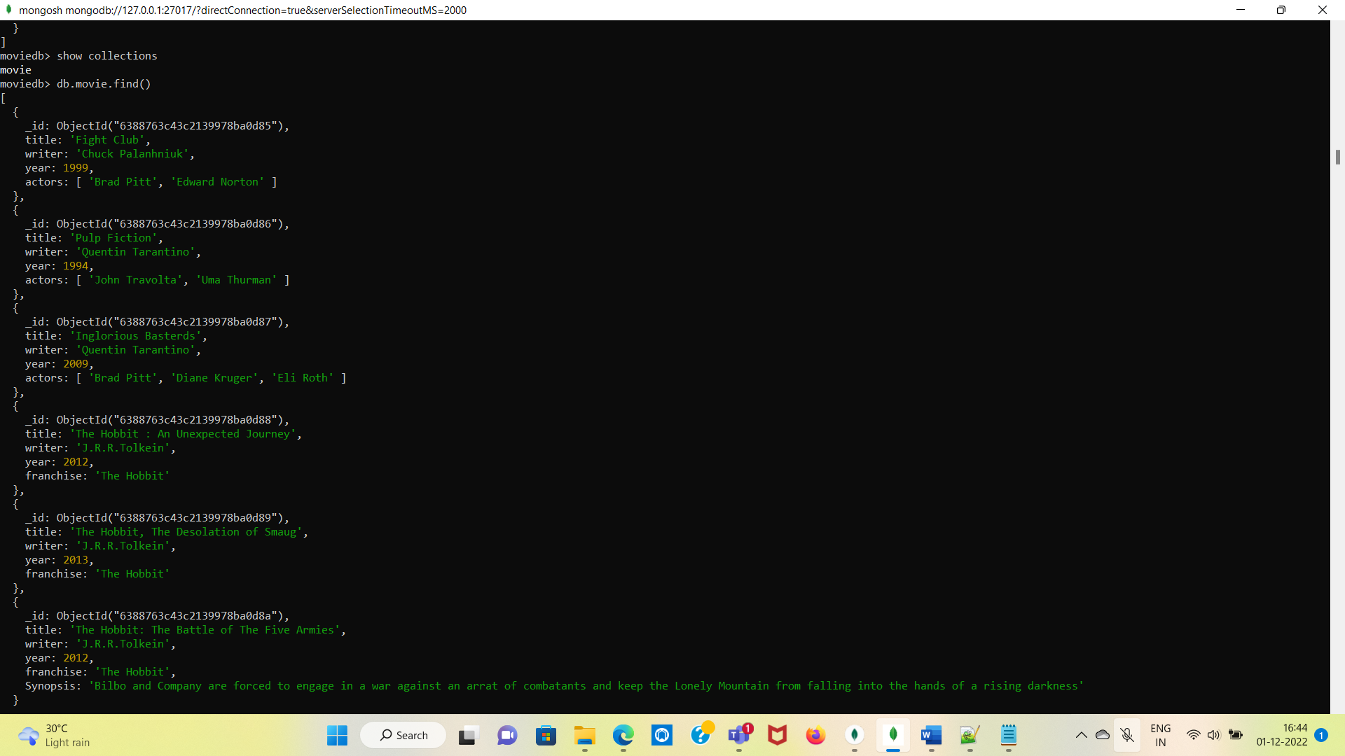

2. get all documents with  writer set to "Quentin Tarantino" ?

->moviedb> db.movie.find({writer:'Quentin Tarantino'})

Output: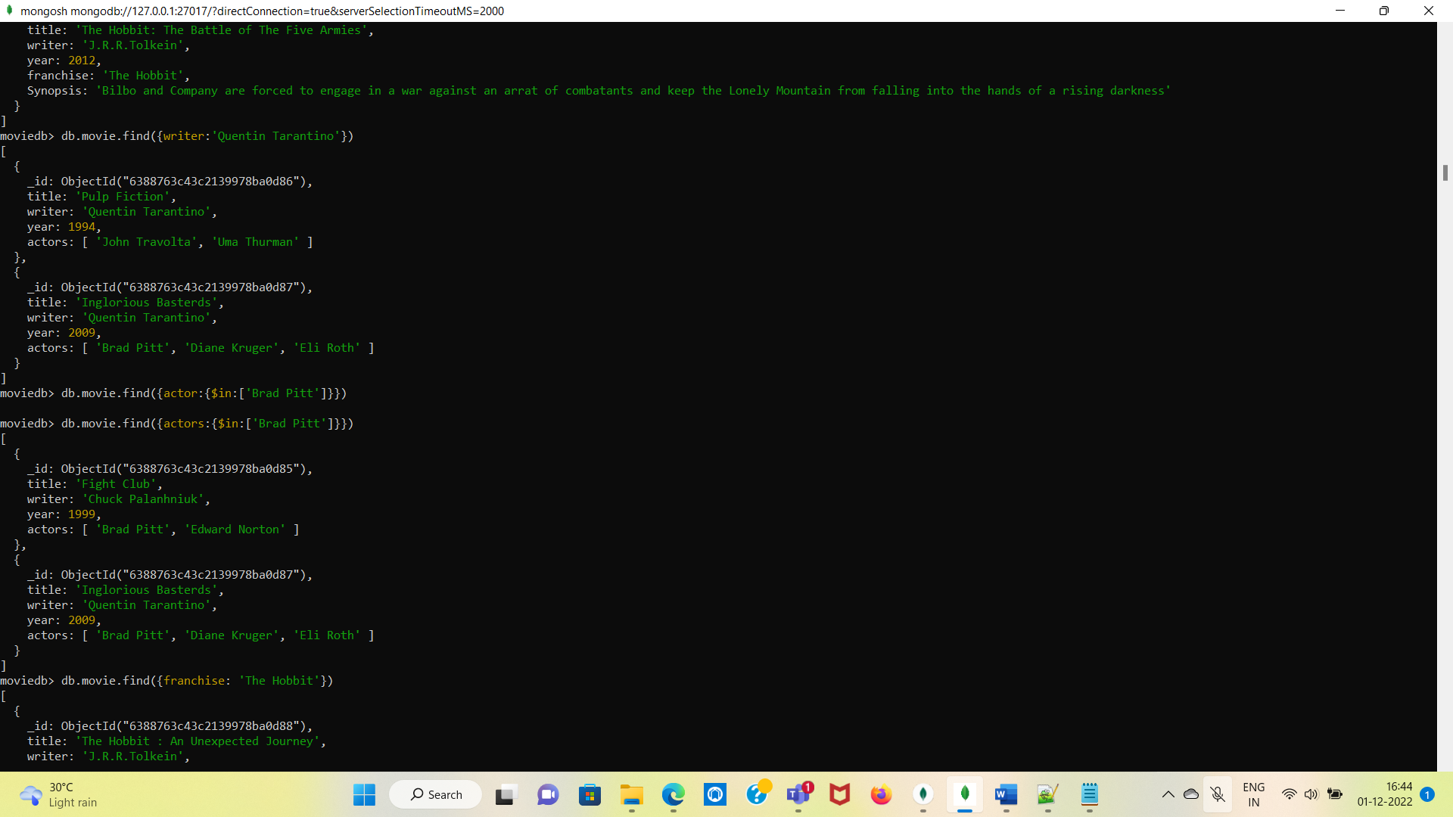

3. get all documents where actors include "Brad Pitt" ?

-> db.movie.find({actors:{$in:['Brad Pitt']}})

Output For 3&4 Questions :

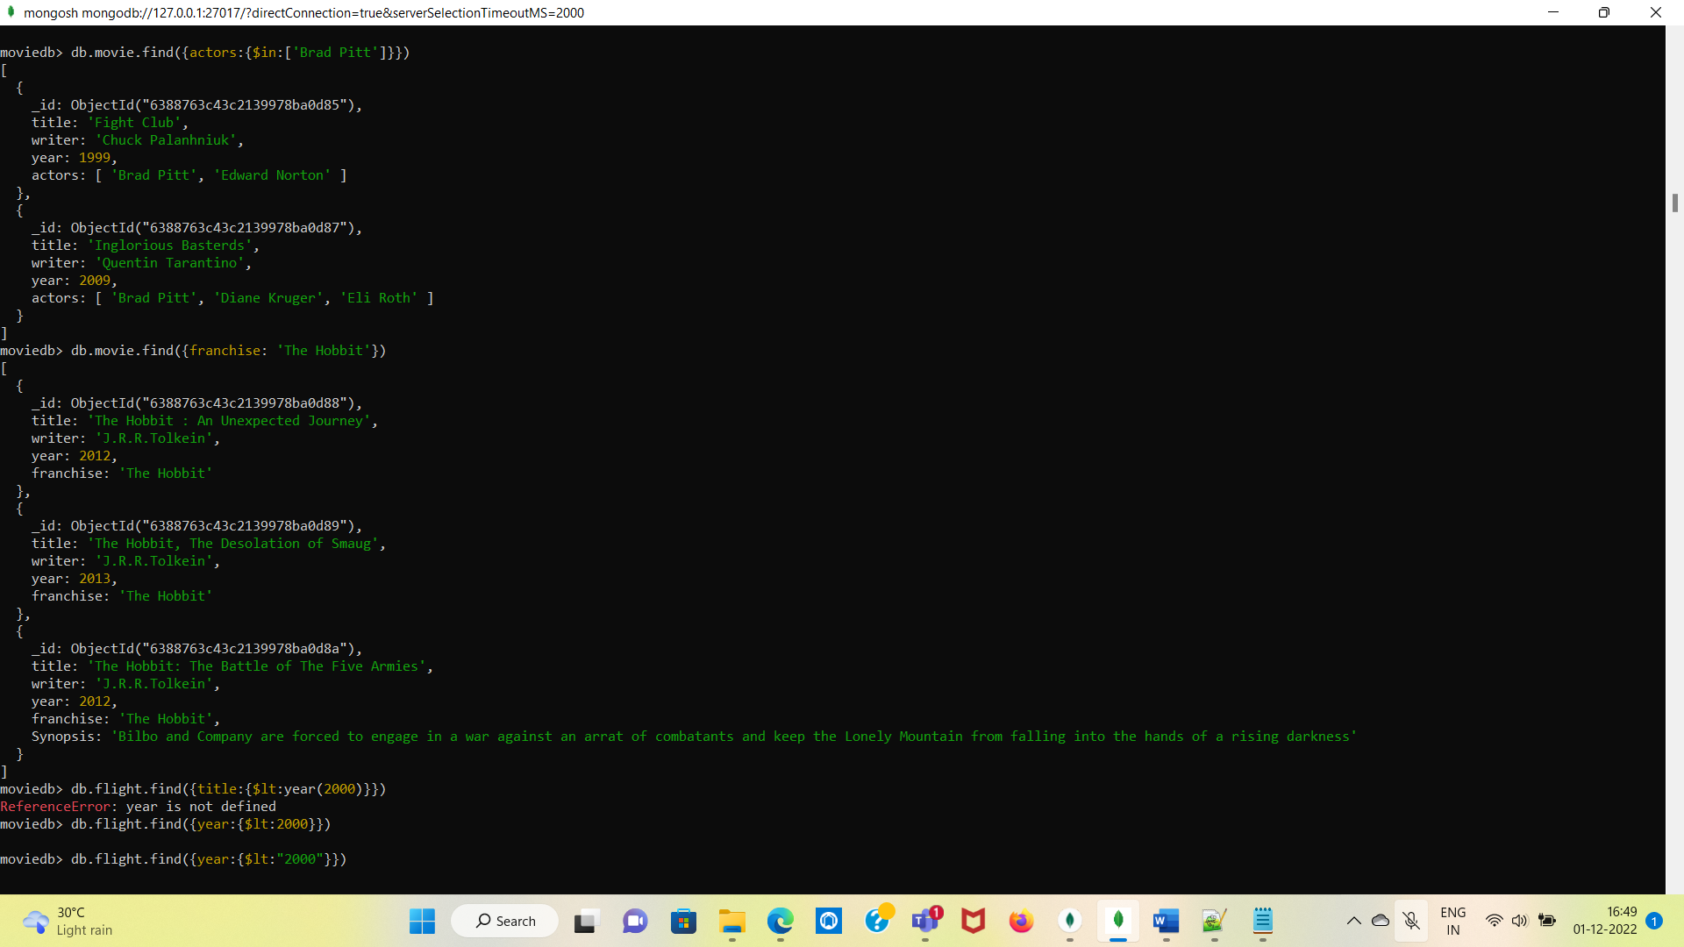

4. get all documents with franchise set to "The Hobbit" ?

-> db.movie.find({franchise: 'The Hobbit'})

-> db.movie.updateMany({$set:{ franchise: 'The Hobbit'}})

5. get all movies released in the 90s ?

-> db.movie.find({year:{$lt:2000}})

Output: 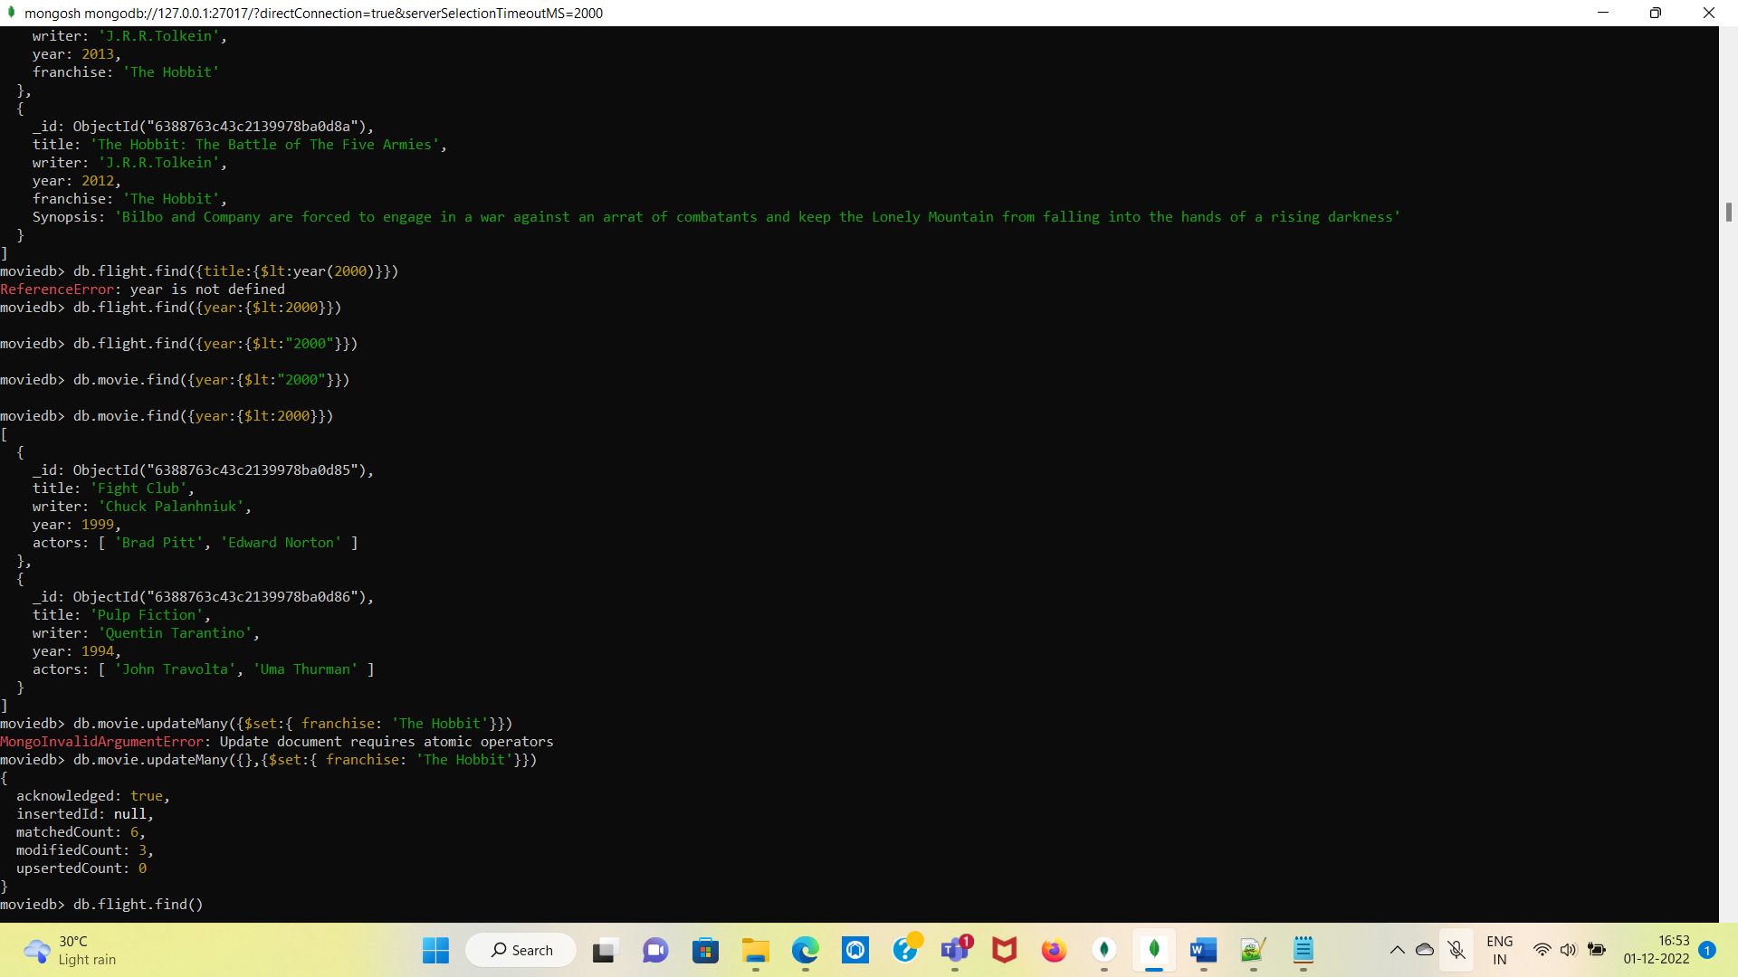

6. get all movies released before the year 2000 or after 2010 ?

-> db.movie.find({$or:[{year:{$lt:2000}},{year:{$gt:2010}}]})

Output: 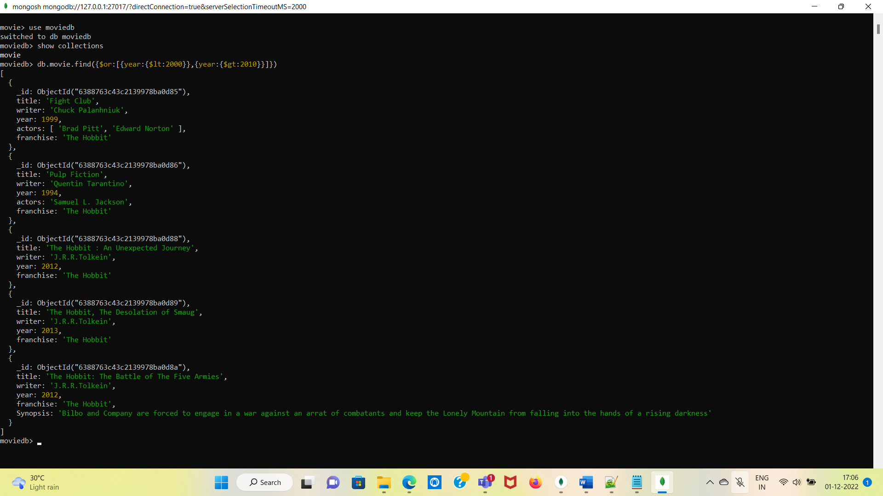

7. count the number of writer from the movie collection ?

-> db.movie.distinct("writer").length

Output:

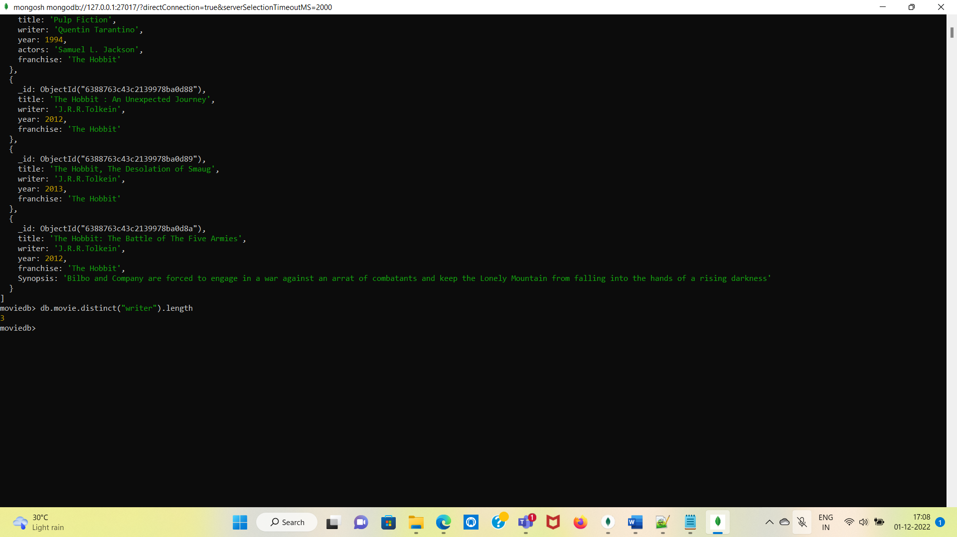

8. update an actor named "Samuel L. Jackson" to the movie "Pulp Fiction" ?

-> db.movie.update({ title:"Pulp Fiction"},{$set:{actors:"Samuel L. Jackson"}})

Output:

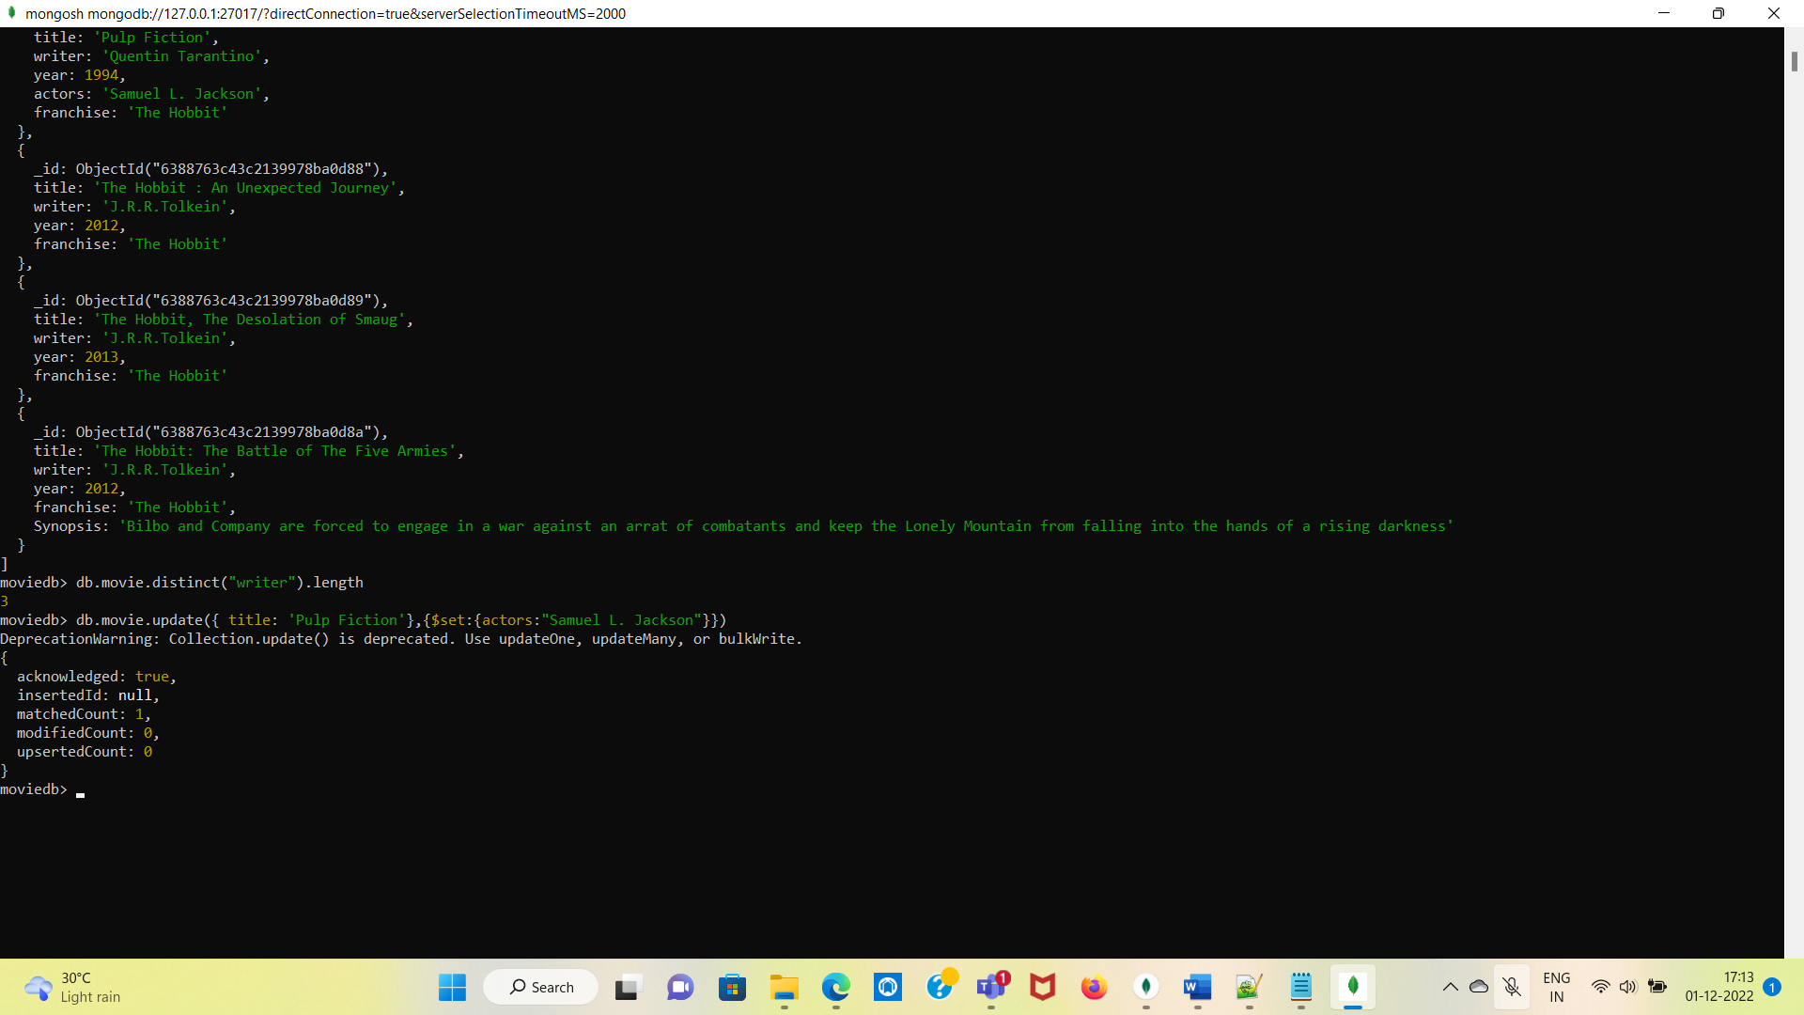

9. find all movies that have a synopsis that contains the word "Gandalf" ?

-> db.movie.find({Synopsis:{$in:["Gandalf"]}})

Output:

Nothing return because of Synopsis does not contain “Gandalf” this word

10. display the movie collection  based on year in descending order.?

-> db.movie.find().sort({year:-1})

Output:

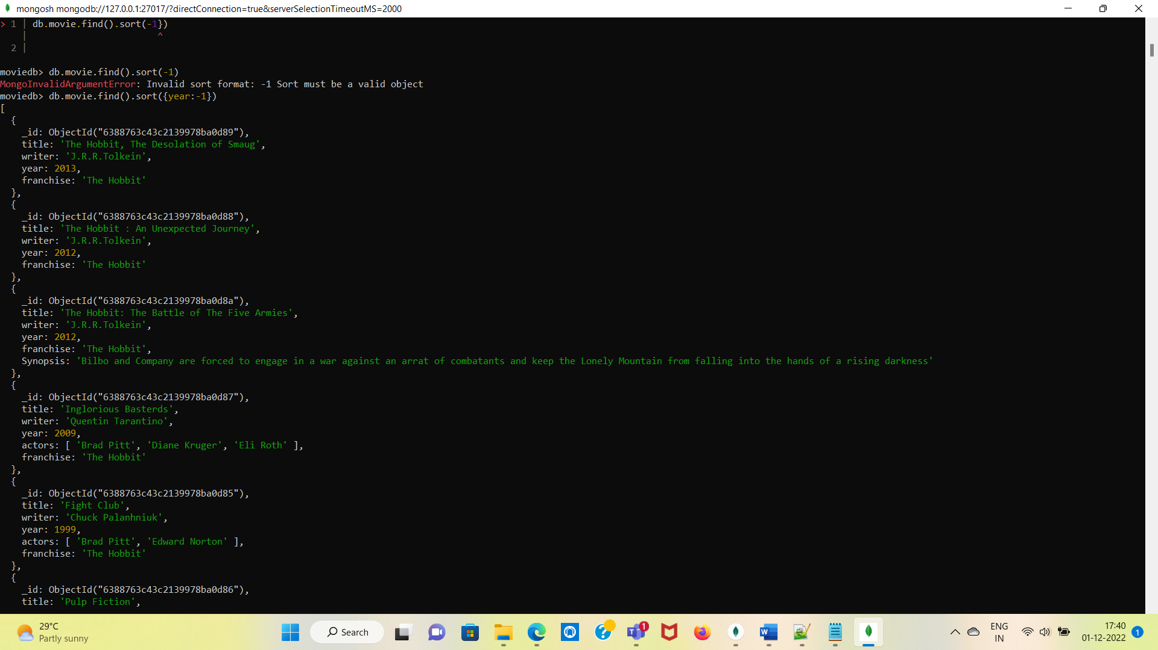

11. Display last two recent movie?

-> moviedb> db.movie.find().limit(2).sort({$natural:-1})

Output:

